
CC-215-L: Database Systems Lab

Faculty of Computing & Information Technology

BS(IT/CS) Morning - Fall 2023
LAB – 02
The objective of this lab is to:
- NVL
- Concatenation
- Like Operator, Order By Clause
- Character & Number Functions
COURSE & LAB INSTRUCTOR: Dr. Asif Sohail
LAB TIMING : 90 MINS
TOTAL MARKS : 45
Task 01: [15 marks]
- Display Employees information whose NAME length is 5. (Use of Length function is not allowed).
SELECT *
FROM EMP
WHERE SUBSTR(ENAME, 6) IS NULL AND SUBSTR(ENAME, 5, 1) IS NOT NULL;
- Write an SQL query to find the date of the employee hired as a President. The query should form as SELECT _______________________________________ = ‘president’
SELECT HIREDATE
FROM EMP
WHERE LOWER(job) = 'president';

- Display the details of all employees whose salary falls within the range of 2001 to 2999, but only if their salary ends with the digit ‘zero’. For example, 2850.
SELECT *
FROM EMP
WHERE SAL BETWEEN 2001 AND 2999 AND MOD(SAL, 10) = 0;

- Increase the Employee’s Salary to the nearest 1000. Display old and new salary.
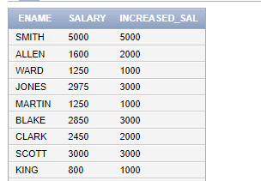
SELECT EMPNO, SAL, CEIL(SAL / 1000) * 1000 AS "new_salary"
FROM EMP;
- Display the Ename, Sal, Comm and Absolute difference between Salary and Commision of the employee.
select ENAME,SAL,COMM,ABS(SAL- NVL(COMM,0)) AS "DIFFERNCE" FROM EMP;
- Display employee names that contain at least one 'A' and sort them by their department number.
SELECT ENAME, DEPTNO
FROM EMP
WHERE ENAME LIKE '%A%'
ORDER BY DEPTNO;

- Display all the employees in the following format. The asterisks indicate the number of digits in the employee's monthly earnings.
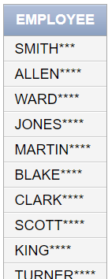
select RPAD(ENAME,10,'*') AS "EMPLOYEE" from EMP;
- Write an SQL query to find the second occurrence index of the word “OR” in the string “CORPORATE FLOOR”.
select INSTR('CORPORATE FLOOR','OR',INSTR('CORPORATE FLOOR','OR') + 1)from DUAL;
- Retrieve the employees who have exactly one ‘A’ in their name. (Use of Character Functions is not allowed)
SELECT *
FROM EMP
WHERE ENAME LIKE '%A%' AND ENAME NOT LIKE '%A%A%';

- Assign the name 'Ghost' to the employee without a name in the emp table and display his details in the specified format.
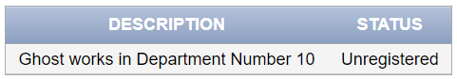
SELECT CONCAT(REPLACE(ENAME,ENAME,'') ,'GHOST works in Department Number ') AS DESCRIPTION, 'Unregistered' AS STATUS
FROM EMP;
- Write an SQL query to display the employee salaries which are perfect squares, excluding zero.
select SAL , SQRT(SAL) AS "SQUARED_SAL"
from EMP
where substr(SQRT(SAL),1) not like '%.%' and sal <> 0;
- Display Employees having NULL commission. The output should display NULL commission as 0.
select ENAME , NVL(COMM,0) AS "UPDATED_COMM"
FROM EMP;
- Remove the letter ‘T’ from the name of the employees who have this letter in their name.
SELECT ename, REPLACE(ename, 'T', '') AS "UPDATED_NAME"
FROM EMP
WHERE INSTR(ename, 'T') > 0

- List all the employees hired in leap years.
SELECT ENAME, HIREDATE, EXTRACT(YEAR FROM HIREDATE) AS "HIRE_IN_LEAPYEAR"
FROM EMP
WHERE (MOD(EXTRACT(YEAR FROM HIREDATE), 4) = 0 AND MOD(EXTRACT(YEAR FROM HIREDATE), 100) <> 0) OR MOD(EXTRACT(YEAR FROM HIREDATE), 400) = 0;

- Write an SQL query to display the last names of all the students in the “PUCIT” table as shown below.
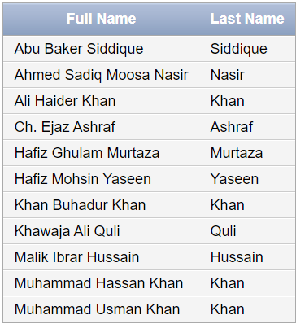
select STD_NAME as FULL_NAME, substr(std_name,instr(STD_NAME ,' ',1,2))as "LAST_NAME"
from PUCIT;
Task 02: [16 marks]
      - Remove the middle letter from the name of the employees with odd number of letters in their name. e.g. ‘SMITH’ becomes ‘SMTH’.
select ENAME,CONCAT(SUBSTR(ENAME,1,LENGTH(ENAME)/2),SUBSTR(ENAME,CEIL(LENGTH(ENAME)/2)+1))
from EMP
WHERE MOD(LENGTH(ENAME),2) <> 0

      - Write an SQL query to display alphabetic codes for each empno. For example, the digit 7 corresponds to the 7th letter of the alphabet, 'G', so the empno '7369' would have the code 'GCFI'. Use appropriate aliasing.
SELECT EMPNO,TRANSLATE(EMPNO,'123456789','ABCDEFGHI')
FROM EMP;
      - Write an SQL query to retrieve the salaries that contain exactly three digits, where the sum of the digits of the salary, each raised to the power of three, is greater than 500. Additionally, display the calculated sum alongside the corresponding salary.
SELECT SAL,POWER(SUBSTR(SAL,1,1),3)+POWER(SUBSTR(SAL,2,1),3)+POWER(SUBSTR(SAL,3,1),3) AS "SUM_SAL"
FROM EMP
WHERE LENGTH(SAL) = 3 AND POWER(SUBSTR(SAL,1,1),3)+POWER(SUBSTR(SAL,2,1),3)+POWER(SUBSTR(SAL,3,1),3) > 500;
      - Write an SQL query to determine whether an employee's name has an even or odd number of letters. Display 'E' for even and 'O' for odd. (Use of Case or Decode is not allowed)
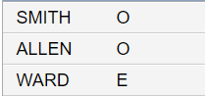
SELECT ENAME,TRANSLATE(MOD(LENGTH(ENAME),2),'01','EO')
FROM EMP;
- Calculate the bonus as 10% of total salary and allowance as 5% of total salary. If the commission is NULL, treat it as 0. Display the total compensation, which is salary + bonus + allowance, rounded to two decimal places. Total salary is the sum of monthly salary and commission.
SELECT SAL,NVL(COMM,0),
(SAL + NVL(COMM,0)) AS "TOTAL_SAL",
(SAL + NVL(COMM,0)*0.1) AS "BONUS_SAL",
(SAL + NVL(COMM,0)*0.5) AS "ALLOWENCE",
(SAL + NVL(COMM,0)) + (SAL + NVL(COMM,0)*0.1) + (SAL + NVL(COMM,0)*0.5) AS "T0TAL_COMPENSATION"
FROM EMP;

- Display the employee code in the format XXX-YY-NN. The first 3 letters of the code are the first 3 letters of ENAME and YY is obtained from the last 2 digits of year in the HIREDATE. NN is the DEPTNO of the employee. Restrict the output to the employees working in DEPTNO 10 or 20.
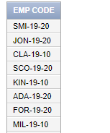
SELECT CONCAT(CONCAT(CONCAT(CONCAT(SUBSTR(ENAME,1,3),'-'),SUBSTR(HIREDATE,7,2)),'-'),DEPTNO)
FROM EMP
WHERE DEPTNO BETWEEN 10 AND 20;
- Write a Query that display’s Employee name alongside its JOB and department number. Display the employees that have a job title of MANAGER. (Use of CONCAT Function or Operator is not allowed).
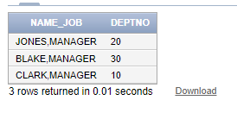
select ENAME || ',' || JOB AS "NAME_JOB" , DEPTNO
FROM EMP
where JOB = 'MANAGER';
- List all employees working in departments 10 and 20, who are either managers or analysts, hired between 1980 and 1981, with a commission less than 100 or no commission, and whose names start with 'S'.
select ENAME
FROM EMP
WHERE DEPTNO in( 10, 20
AND JOB IN ('MANAGER','ANALYST')
AND (SUBSTR(HIREDATE,7,4) = '1980' OR SUBSTR(HIREDATE,7,4) = '1981')
AND (COMM < 100)
AND ENAME LIKE 'S%'

Task 03: [9 marks]
- Write an SQL query to check if an employee’s salary is greater than or less than 1000. The output should be like the following. (Use of Case or Decode is not allowed)
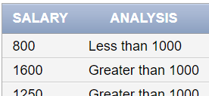
SELECT SAL, NVL2(NULLIF(SIGN(SAL-1000),-1),'GREATER THAN 1000','LESS
THAN 1000') ANALYSIS FROM EMP

- Count and display the number of vowels in each employee’s name, and also show the employee’s name alongside the count.
SELECT ENAME , LENGTH(ENAME) - LENGTH(REPLACE(TRANSLATE(ENAME,'AEIOU','00000'),'0',''))AS "COUNT"
FROM EMP;
- Select all the employees from emp table and display a column such that the first 2 digits of empno are concatenated with the last half of the name. Also add number of dollar Sign ‘$’ to the left and right side, equal to the length of the name.
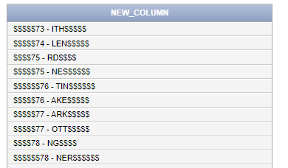
SELECT ENAME, LPAD(SUBSTR(EMPNO,1,2),LENGTH(ENAME) + 2,'$') || ' - ' || RPAD(SUBSTR(ENAME,FLOOR(LENGTH(ENAME)/2) + 1),LENGTH(ENAME)+ CEIL(LENGTH(ENAME)/2),'$') AS "NEW_COLOUMN"
FROM EMP;
Task 04: [5 marks]
VIVA VOCE

